Project 3 Proposal

Group Members: Amy Baker, Alexis Fallow, Colleen Karworski, & Dan Lee

Project Git Hub link - <https://github.com/ColleenKarwoski/Project-3.git>

Sources:

META DATA FOUND IN THIS LINK From Kaggle <https://www.kaggle.com/datasets/michaelbryantds/internet-speeds-and-prices?select=speed_price_centurylink.csv>

Git Hub - <https://github.com/the-markup/investigation-isp>

Article - <https://themarkup.org/show-your-work/2022/10/19/how-we-uncovered-disparities-in-internet-deals>

Data houses:

SQLite

Topic:

Looking at Demographics in the USA and the effects on internet service. We will be looking at the internet speed, price, population, household income, and providers. These different factors will provide insight on our questions below.

Visualizations Inspiration

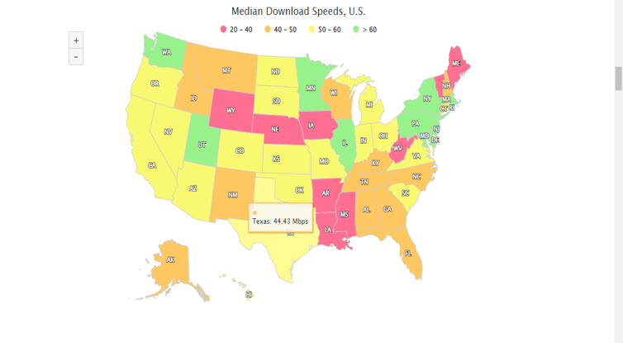

website mockup



Sources



graph

